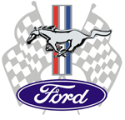
Door Prizes Sun Shine
Event Only

Central New York Mustang & All Ford Club
Presents Our Annual Summer “Tuesday Night Cruise In"

June 17, July 1
July 15 & 29 - August 12 & 26

5:30 to dusk
Cort Lanes Bowling Alley - Tompkins St. Ext, Cortland

Music, Food, Prizes, 50/50
All Classic Cars, Rods, Restomods are Welcome
www.cnymustang-allford.com

